Kamil Gumienny  
Prof. Wills  
CS3013  
10/10/2019

**Project 4 Thread Timing Analysis**

My testing environment for this part of the project was an Ubuntu container with 6 CPU cores, 7GB of memory, and hardware virtualization enabled. It is the default ubuntu container provided by Prof. Ciaraldi for CS2303. I used two directories to test the performance of my code, the /etc/ directory and /bin/ directory.

* /etc/* has 221 files
* /bin/* has 163 file

The performance of my program can be summarized with the excel sheet below.

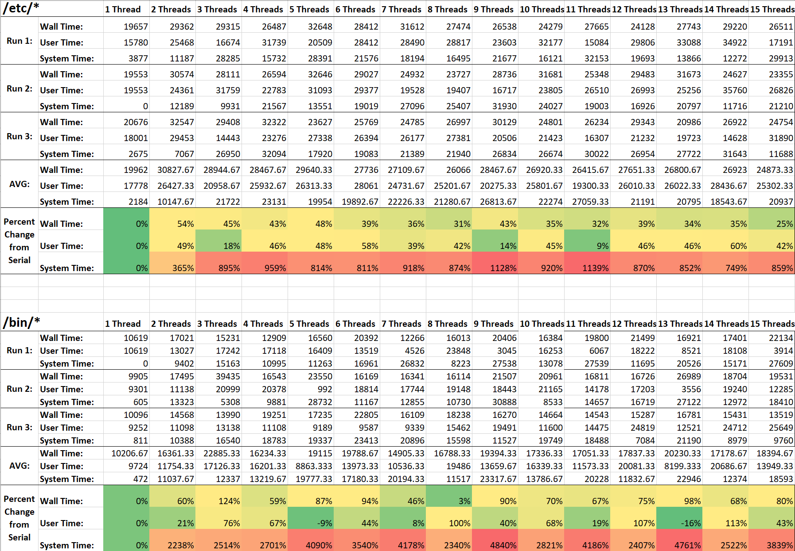

The best performance for scanning these directories was using the serial approach using only the main thread to analyze files. There were a few instances where one of the timings for the thread implementations did better on average than the serial approach, such as in the /bin/ directory with 5 threads running regarding user time. There doesn’t seem to be much correlation between how many threads there are from my testing. In the /etc/ directory, the wall time decreased from only 2 threads to 15 threads but this is not evident in the /bin/ directory. This can be since other processes may have been running in the background during my testing that interfered with the results. The results also don’t capture much of the data as they only test 3 runs for each thread count in each directory that have a 60 file difference (163 vs 221). Further testing would be needed for more concrete results but from there it appears the serial architecture worked better.